City Day City Night Parking Instructions
The Capital Plaza Hotel’s parking garage is currently under construction. The hotel staff has provided instructions for alternative parking. See below for a map of where the hotel is located (405 Wilkinson Boulevard, Frankfort, KY 40601). Board members arriving for the 8:00 a.m. Board of Directors meeting on Wednesday morning, please park across the street in the Market Pavilion/River View Park Lot.
For the City Day/City Night Event, parking is available in the Mayo Underwood Building’s parking garage located at 500 Mero Street (park on any of the four floors); however, please note that your vehicle will need to be moved before 8:00 a.m. We only have permission to park in this garage for the City Day/City Night Event. We were advised that vehicles may be towed if they are not moved by 8:00 a.m. Thursday morning (state employees use the garage Monday – Friday 8:00 a.m. – 4:30 p.m.)
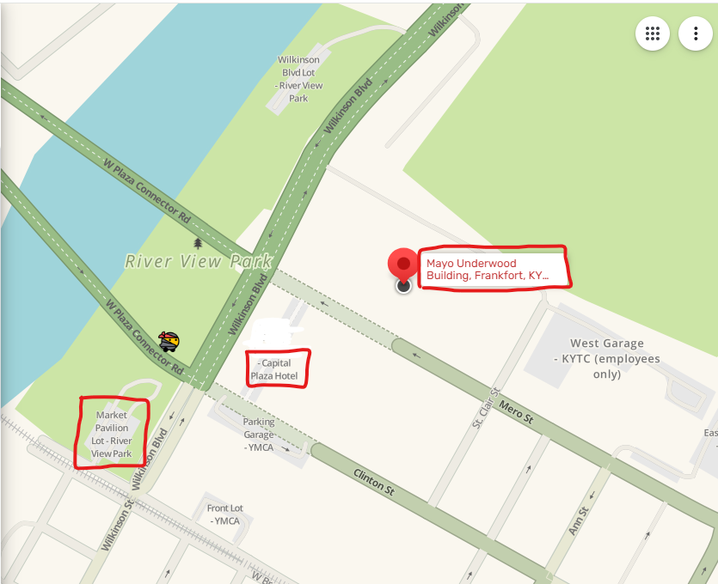

Driving Directions to Mayo-Underwood Building
500 Mero Street, Frankfort, KY 40601

From the west (Louisville)
From the west on I-64, take Frankfort exit #53B onto U.S. Hwy. 127 toward Frankfort
(north from Lawrenceburg).
Stay straight on U.S. 127 and go over the river.
Get in the right-hand lane and go through the first light.
Make a left at the 4-way stop on to St. Clair Street.
Go straight through the next 4-way stop into the parking structure.
Park on any of the four floors

From the east (Lexington)
From the east on I-64, take the US-60 exit, EXIT #53B (2ndFrankfort exit), onto the U.S. Hwy.127.
Stay straight on U.S. 127 and go over the river.
Get in the right-hand lane and go through the first light.
Make a left at the 4-way stop on to St. Clair Street.
Go straight through the next 4-way stop into the parking structure.
Park on any of the four floors

Alternate route from east (Lexington) via East-West Connector
From the east on I-64, take the 2nd
Frankfort exit #53B onto U.S. Hwy.
Turn right onto U.S. 60 (east from Versailles).
At the junction of U.S. 60 and U.S. 421, turn left onto state route 676 (East-West
Connector).
Continue on the East-West Connector and make a right onto Limestone (the street sign is on the left side of road, you will turn between McDonald’s and Shell)
Make a right at the next light onto U.S. Hwy 127 and get in the left-hand lane.
Stay straight on U.S. 127 and go over the river.
Get in the right-hand lane and go through the first light.
Make a left at the 4-way stop onto St. Clair Street.
Go straight through the next 4-way stop into the parking structure.
Park on any of the four floors.

